Corporate Finance, (Berk/DeMarzo)
Chapter 12 Estimating the Cost of Capital

12.1 The Equity Cost of Capital

Use the following information to answer the question(s) below.

 | Beta | Volatility
"Eenie" | 0.45 | 20%
"Meenie" | 0.75 | 18%
"Miney" | 1.05 | 35%
"Moe" | 1.20 | 25%

Assume that the risk-free rate of interest is 3% and you estimate the market's expected return to be 9%.

1) Which firm has the most total risk?
A) Eenie
B) Meenie
C) Miney
D) Moe
Answer: C
Explanation: C) Total risk is measured using volatility and Miney has the highest volatility, hence the most total risk.
Diff: 1
Section: 12.1 The Equity Cost of Capital
Skill: Analytical

2) Which firm has the least market risk?
A) Eenie
B) Meenie
C) Miney
D) Moe
Answer: A
Explanation: A) Market risk is measured using beta and Eenie has the lowest beta, hence the lowest market risk.
Diff: 1
Section: 12.1 The Equity Cost of Capital
Skill: Analytical

3) Which firm has the highest cost of equity capital?
A) Eenie
B) Meenie
C) Miney
D) Moe
Answer: D
Explanation: D) Cost of capital is measured using the CAPM and is a linear function of beta. Therefore the firm with the highest beta (Moe) has the highest cost of equity capital.
Diff: 1
Section: 12.1 The Equity Cost of Capital
Skill: Analytical
4) The equity cost of capital for "Miney" is closest to:
A) 6.30%
B) 7.50%
C) 9.30%
D) 9.75%
Answer: C
Explanation: C) rMiney = 3% + 1.05(9% - 3%) = 9.3%
Diff: 1
Section: 12.1 The Equity Cost of Capital
Skill: Analytical

5) The equity cost of capital for "Meenie" is closest to:
A) 4.50%
B) 7.50%
C) 9.30%
D) 9.75%
Answer: B
Explanation: B) rMeenie = 3% + 0.75(9% - 3%) = 7.5%
Diff: 1
Section: 12.1 The Equity Cost of Capital
Skill: Analytical

6) The risk premium for "Meenie" is closest to:
A) 4.50%
B) 7.50%
C) 9.30%
D) 9.75%
Answer: A
Explanation: A) risk premiumMeenie = 0.75(9% - 3%) = 4.5%
Diff: 2
Section: 12.1 The Equity Cost of Capital
Skill: Analytical
12.2 The Market Portfolio

Use the following information to answer the question(s) below.

Suppose all possible investment opportunities in the world are limited to the four stocks list in the table below:

Stock | Price per  Share | Number of Shares  Outstanding (Millions)
Taggart Transcontinental | $15.60 | 25
Rearden Metal | $13.00 | 45
Wyatt Oil | $29.25 | 10
Nielson Motors | $26.25 | 26

1) The weight on Taggart Transcontinental stock in the market portfolio is closest to:
A) 15%
B) 20%
C) 25%
D) 30%
Answer: B
Explanation: B)
Calculations |  |  | B × C | D/1950
Stock | Price per  Share | Number of Shares  Outstanding  (Millions) | Market  Cap | Weight
Taggart Transcontinental | $15.60 | 25 | $390.00 | 0.2
Rearden Metal | $13.00 | 45 | $585.00 | 0.3
Wyatt Oil | $29.25 | 10 | $292.50 | 0.15
Nielson Motors | $26.25 | 26 | $682.50 | 0.35
Total |  |  | $1950.00
Diff: 1
Section: 12.2 The Market Portfolio
Skill: Analytical
2) The weight on Wyatt Oil stock in the market portfolio is closest to:
A) 15%
B) 20%
C) 25%
D) 30%
Answer: A
Explanation: A)
Calculations |  |  | B × C | D/1950
Stock | Price per  Share | Number of Shares  Outstanding  (Millions) | Market  Cap | Weight
Taggart Transcontinental | $15.60 | 25 | $390.00 | 0.2
Rearden Metal | $13.00 | 45 | $585.00 | 0.3
Wyatt Oil | $29.25 | 10 | $292.50 | 0.15
Nielson Motors | $26.25 | 26 | $682.50 | 0.35
Total |  |  | $1950.00
Diff: 1
Section: 12.2 The Market Portfolio
Skill: Analytical

3) Suppose that you are holding a market portfolio and you have invested $9,000 in Rearden Metal. The amount that you have invested in Nielson Motors is closest to:
A) $6,000
B) $7,715
C) $9,000
D) $10,500
Answer: D
Explanation: D)
Calculations |  |  | B × C | D/1950
Stock | Price per  Share | Number of Shares  Outstanding  (Millions) | Market  Cap | Weight
Taggart Transcontinental | $15.60 | 25 | $390.00 | 0.2
Rearden Metal | $13.00 | 45 | $585.00 | 0.3
Wyatt Oil | $29.25 | 10 | $292.50 | 0.15
Nielson Motors | $26.25 | 26 | $682.50 | 0.35
Total |  |  | $1950.00

AmountNielson = 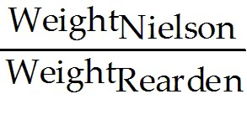 × AmountRearden = 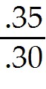 × $9,000 = $10,500
Diff: 2
Section: 12.2 The Market Portfolio
Skill: Analytical
4) Suppose that you are holding a market portfolio and you have invested $9,000 in Rearden Metal. The amount that you have invested in Taggart Transcontinental is closest to:
A) $4,500
B) $6,000
C) $7,715
D) $9,000
Answer: B
Explanation: B)
Calculations |  |  | B × C | D/1950
Stock | Price per  Share | Number of Shares  Outstanding  (Millions) | Market  Cap | Weight
Taggart Transcontinental | $15.60 | 25 | $390.00 | 0.2
Rearden Metal | $13.00 | 45 | $585.00 | 0.3
Wyatt Oil | $29.25 | 10 | $292.50 | 0.15
Nielson Motors | $26.25 | 26 | $682.50 | 0.35
Total |  |  | $1950.00

AmountNielson = 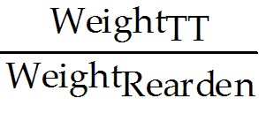 × AmountRearden = 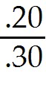 × $9,000 = $6,000
Diff: 2
Section: 12.2 The Market Portfolio
Skill: Analytical

5) Suppose that you have invested $30,000 invested in the market portfolio. Then the amount that you have invested in Wyatt Oil is closest to:
A) $4,500
B) $6,000
C) $7,715
D) $9,000
Answer: A
Explanation: A)
Calculations |  |  | B × C | D/1950
Stock | Price per  Share | Number of Shares  Outstanding  (Millions) | Market  Cap | Weight
Taggart Transcontinental | $15.60 | 25 | $390.00 | 0.2
Rearden Metal | $13.00 | 45 | $585.00 | 0.3
Wyatt Oil | $29.25 | 10 | $292.50 | 0.15
Nielson Motors | $26.25 | 26 | $682.50 | 0.35
Total |  |  | $1950.00

AmountWO = WeightWO × AmountMarket = .15 × $30,000 = $4,500
Diff: 2
Section: 12.2 The Market Portfolio
Skill: Analytical
6) Suppose that you have invested $30,000 in the market portfolio. Then the number of shares of Rearden Metal that you hold is closest to:
A) 450 shares
B) 700 shares
C) 1,400 shares
D) 2,300 shares
Answer: B
Explanation: B)
Calculations |  |  | B × C | D/1950
Stock | Price per  Share | Number of Shares  Outstanding  (Millions) | Market  Cap | Weight
Taggart Transcontinental | $15.60 | 25 | $390.00 | 0.2
Rearden Metal | $13.00 | 45 | $585.00 | 0.3
Wyatt Oil | $29.25 | 10 | $292.50 | 0.15
Nielson Motors | $26.25 | 26 | $682.50 | 0.35
Total |  |  | $1950.00

SharesRM = 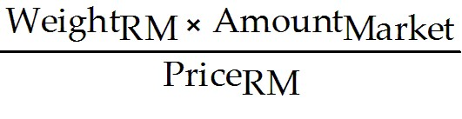 = 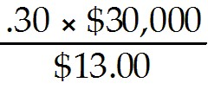 = 692.31 shares
Diff: 2
Section: 12.2 The Market Portfolio
Skill: Analytical

7) Suppose that you have invested $30,000 in the market portfolio. Then the number of shares of Wyatt Oil that you hold is closest to:
A) 150 shares
B) 300 shares
C) 350 shares
D) 450 shares
Answer: A
Explanation: A)
Calculations |  |  | B × C | D/1950
Stock | Price per  Share | Number of Shares  Outstanding  (Millions) | Market  Cap | Weight
Taggart Transcontinental | $15.60 | 25 | $390.00 | 0.2
Rearden Metal | $13.00 | 45 | $585.00 | 0.3
Wyatt Oil | $29.25 | 10 | $292.50 | 0.15
Nielson Motors | $26.25 | 26 | $682.50 | 0.35
Total |  |  | $1950.00

SharesWO = 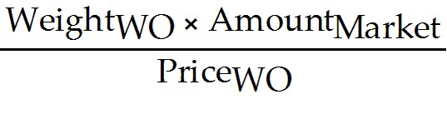 = 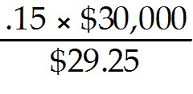 = 153.85 shares
Diff: 2
Section: 12.2 The Market Portfolio
Skill: Analytical
8) Suppose that you are holding a market portfolio and you have invested $18,000 in Taggart Transcontinental. The number of shares of Wyatt Oil that you hold is closest to:
A) 90 shares
B) 460 shares
C) 615 shares
D) 770 shares
Answer: B
Explanation: B)
Calculations |  |  | B × C | D/1950
Stock | Price per  Share | Number of Shares  Outstanding  (Millions) | Market  Cap | Weight
Taggart Transcontinental | $15.60 | 25 | $390.00 | 0.2
Rearden Metal | $13.00 | 45 | $585.00 | 0.3
Wyatt Oil | $29.25 | 10 | $292.50 | 0.15
Nielson Motors | $26.25 | 26 | $682.50 | 0.35
Total |  |  | $1950.00

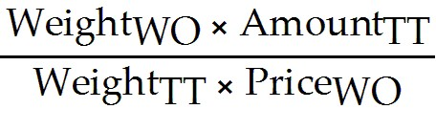 = 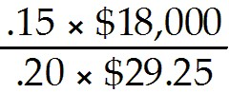 = 461.54 shares
Diff: 2
Section: 12.2 The Market Portfolio
Skill: Analytical

9) Suppose that you are holding a market portfolio and you have invested $18,000 in Taggart Transcontinental. The number of shares of Rearden Metal that you hold is closest to:
A) 780 shares
B) 925 shares
C) 1,730 shares
D) 2,075 shares
Answer: B
Explanation: B)
Calculations |  |  | B × C | D/1950
Stock | Price per  Share | Number of Shares  Outstanding  (Millions) | Market  Cap | Weight
Taggart Transcontinental | $15.60 | 25 | $390.00 | 0.2
Rearden Metal | $13.00 | 45 | $585.00 | 0.3
Wyatt Oil | $29.25 | 10 | $292.50 | 0.15
Nielson Motors | $26.25 | 26 | $682.50 | 0.35
Total |  |  | $1950.00

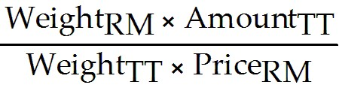 = 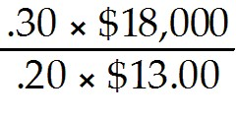 = 2,076.92 shares
Diff: 2
Section: 12.2 The Market Portfolio
Skill: Analytical
10) Suppose that you have invested $100,000 invested in the market portfolio and that the stock price of Taggart Transcontinental suddenly drops to $7.80 per share. Which of the following trades would you need to make in order to maintain your investment in the market portfolio:
1. Buy approximately 1,140 shares of Taggart Transcontinental
2. Sell approximately 256 shares of Rearden Metal
3. Sell approximately 57 shares of Wyatt Oil
4. Sell approximately 148 shares of Nielson Motors
A) 1 only
B) 2 only
C) 2, 3, and 4 only
D) 1, 2, 3, and 4
E) None of the above
Answer: E
Explanation: E) There is no need to rebalance your portfolio. As an investor, you still hold the market portfolio and therefore there are no trades needed.
Diff: 3
Section: 12.2 The Market Portfolio
Skill: Analytical

Use the following information to answer the question(s) below.

Suppose that Merck (MRK) stock is trading for $36.70 per share with 2.11 billion shares outstanding while Boeing (BA) has 697.5 million shares outstanding and a market capitalization of $38.223 billion. Assume that you hold the market portfolio.

11) Boeing's stock price is closest to:
A) $18.25
B) $36.70
C) $54.80
D) $63.40
Answer: C
Explanation: C) PriceBA = 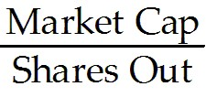 = 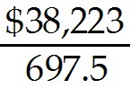 = $54.80
Diff: 1
Section: 12.2 The Market Portfolio
Skill: Analytical

12) Merck's market capitalization is closest to:
A) $38.2 billion
B) $77.4 billion
C) $89.4 billion
D) $115.6 billion
Answer: B
Explanation: B) Market Cap = Price × shares outstanding = $36.70 × 2,110 = $77,437 million
Diff: 1
Section: 12.2 The Market Portfolio
Skill: Analytical
13) If you hold 1,000 shares of Merck, then the number of shares of Boeing that you hold is closest to:
A) 240 shares
B) 330 shares
C) 510 shares
D) 780 shares
Answer: B
Explanation: B) SharesBA = 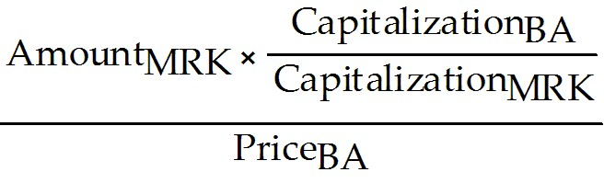
= 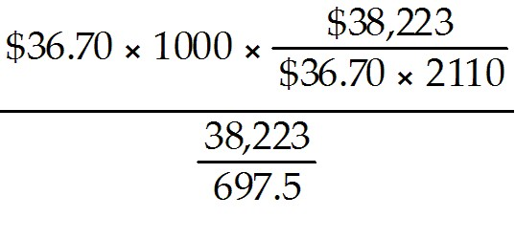 = 330.57 shares
Diff: 3
Section: 12.2 The Market Portfolio
Skill: Analytical

14) Which of the following statements is FALSE?
A) All investors should demand the same efficient portfolio of securities in the same proportions.
B) The Capital Asset Pricing Model (CAPM) allows corporate executives to identify the efficient portfolio (of risky assets) by using knowledge of the expected return of each security.
C) If investors hold the efficient portfolio, then the cost of capital for any investment project is equal to its required return calculated using its beta with the efficient portfolio.
D) The CAPM identifies the market portfolio as the efficient portfolio.
Answer: B
Diff: 1
Section: 12.2 The Market Portfolio
Skill: Conceptual

15) Which of the following statements is FALSE?
A) If investors have homogeneous expectations, then each investor will identify the same portfolio as having the highest Sharpe ratio in the economy.
B) Homogeneous expectations are when all investors have the same estimates concerning future investments and returns.
C) There are many investors in the world, and each must have identical estimates of the volatilities, correlations, and expected returns of the available securities.
D) The combined portfolio of risky securities of all investors must equal the efficient portfolio.
Answer: C
Diff: 1
Section: 12.2 The Market Portfolio
Skill: Conceptual
16) Which of the following statements is FALSE?
A) If some security were not part of the efficient portfolio, then every investor would want to own it, and demand for this security would increase causing its expected return to fall until it is no longer an attractive investment.
B) The efficient portfolio, the portfolio that all investors should hold, must be the same portfolio as the market portfolio of all risky securities.
C) Because every security is owned by someone, the sum of all investors' portfolios must equal the portfolio of all risky securities available in the market.
D) If all investors demand the efficient portfolio, and since the supply of securities is the market portfolio, then two portfolios must coincide.
Answer: A
Diff: 2
Section: 12.2 The Market Portfolio
Skill: Conceptual

17) Which of the following statements is FALSE?
A) The market portfolio contains more of the smallest stocks and less of the larger stocks.
B) For the market portfolio, the investment in each security is proportional to its market capitalization.
C) Because the market portfolio is defined as the total supply of securities, the proportions should correspond exactly to the proportion of the total market that each security represents.
D) Market capitalization is the total market value of the outstanding shares of a firm.
Answer: A
Diff: 1
Section: 12.2 The Market Portfolio
Skill: Conceptual

18) Which of the following statements is FALSE?
A) A value-weighted portfolio is an equal-ownership portfolio: We hold an equal fraction of the total number of shares outstanding of each security in the portfolio.
B) When buying a value-weighted portfolio, we end up purchasing the same percentage of shares of each firm.
C) To maintain a value-weighted portfolio, we do not need to trade securities and rebalance the portfolio unless the number of shares outstanding of some security changes.
D) In a value weighted portfolio the fraction of money invested in any security corresponds to its share of the total number of shares outstanding of all securities in the portfolio.
Answer: D
Diff: 1
Section: 12.2 The Market Portfolio
Skill: Conceptual
19) Which of the following statements is FALSE?
A) The most familiar stock index in the United States is the Dow Jones Industrial Average (DJIA).
B) A portfolio in which each security is held in proportion to its market capitalization is called a price-weighted portfolio.
C) The Dow Jones Industrial Average (DJIA) consists of a portfolio of 30 large industrial stocks.
D) The Dow Jones Industrial Average (DJIA) is a price-weighted portfolio.
Answer: B
Explanation: B) A portfolio in which each security is held in proportion to its market capitalization is called a value-weighted portfolio.
Diff: 2
Section: 12.2 The Market Portfolio
Skill: Conceptual

20) Which of the following statements is FALSE?
A) Because very little trading is required to maintain it, an equal-weighted portfolio is called a passive portfolio.
B) If the number of shares in a value weighted portfolio does not change, but only the prices change, the portfolio will remain value weighted.
C) The CAPM says that individual investors should hold the market portfolio, a value-weighted portfolio of all risky securities in the market.
D) A price weighted portfolio holds an equal number of shares of each stock, independent of their size.
Answer: A
Explanation: A) Because very little trading is required to maintain it, a value-weighted portfolio is called a passive portfolio.
Diff: 3
Section: 12.2 The Market Portfolio
Skill: Conceptual

21) Which of the following statements is FALSE?
A) A market index reports the value of a particular portfolio of securities.
B) The S&P 500 is the standard portfolio used to represent "the market" when using the CAPM in practice.
C) Even though the S&P 500 includes only 500 of the more than 7,000 individual U.S. Stocks in existence, it represents more than 70% of the U.S. stock market in terms of market capitalization.
D) The S&P 500 is an equal-weighted portfolio of 500 of the largest U.S. stocks.
Answer: D
Explanation: D) The S&P 500 is a value-weighted portfolio of 500 of the largest U.S. stocks.
Diff: 2
Section: 12.2 The Market Portfolio
Skill: Conceptual
22) Which of the following statements is FALSE?
A) The S&P 500 and the Wilshire 5000 indexes are both well-diversified indexes that roughly correspond to the market of U.S. stocks.
B) Practitioners commonly use the S&P 500 as the market portfolio in the CAPM with the belief that this index is the market portfolio.
C) Standard & Poor's Depository Receipts (SPDR, nicknamed "spider") trade on the American Stock Exchange and represent ownership in the S&P 500.
D) The S&P 500 was the first widely publicized value weighted index and it has become a benchmark for professional investors.
Answer: B
Diff: 2
Section: 12.2 The Market Portfolio
Skill: Conceptual

23) In practice which market index is most widely used as a proxy for the market portfolio in the CAPM?
A) Dow Jones Industrial Average
B) Wilshire 5000
C) S&P 500
D) U.S. Treasury Bill
Answer: C
Diff: 1
Section: 12.2 The Market Portfolio
Skill: Conceptual

24) In practice which market index would best be used as a proxy for the market portfolio in the CAPM?
A) S&P 500
B) Dow Jones Industrial Average
C) U.S. Treasury Bill
D) Wilshire 5000
Answer: D
Diff: 1
Section: 12.2 The Market Portfolio
Skill: Conceptual
Use the table for the question(s) below.

Consider the following stock price and shares outstanding data:

Stock Name | Price per Share | Shares Outstanding (Billions)
Lowes | $28.80 | 1.53
Wal-Mart | $47.90 | 4.17
Intel | $19.60 | 5.77
Boeing | $75.00 | 0.79

25) The market capitalization for Wal-Mart is closest to:
A) $415 Billion
B) $276 Billion
C) $479 Billion
D) $200 Billion
Answer: D
Explanation: D)
Stock Name | Price per Share | Shares Outstanding (Billions) | Market Capitalization (Billions)
Lowes | $28.80 | 1.53 | $44.06
Wal-Mart | $47.90 | 4.17 | $199.74
Intel | $19.60 | 5.77 | $113.09
Boeing | $75.00 | 0.79 | $59.25
 |  | Total | $416.15
Diff: 1
Section: 12.2 The Market Portfolio
Skill: Analytical

26) The total market capitalization for all four stocks is closest to:
A) $479 Billion
B) $415 Billion
C) $2,100 Billion
D) $200 Billion
Answer: B
Explanation: B)
Stock Name | Price per Share | Shares Outstanding (Billions) | Market Capitalization (Billions)
Lowes | $28.80 | 1.53 | $44.06
Wal-Mart | $47.90 | 4.17 | $199.74
Intel | $19.60 | 5.77 | $113.09
Boeing | $75.00 | 0.79 | $59.25
 |  | Total | $416.15
Diff: 1
Section: 12.2 The Market Portfolio
Skill: Analytical
27) If you are interested in creating a value-weighted portfolio of these four stocks, then the percentage amount that you would invest in Lowes is closest to:
A) 25%
B) 11%
C) 20.0%
D) 12%
Answer: B
Explanation: B)
Stock Name | Price per Share | Shares Outstanding (Billions) | Market Capitalization (Billions) | Percent of Total
Lowes | $28.80 | 1.53 | $44.06 | 10.6%
Wal-Mart | $47.90 | 4.17 | $199.74 | 48.0%
Intel | $19.60 | 5.77 | $113.09 | 27.2%
Boeing | $75.00 | 0.79 | $59.25 | 14.2%
 |  | Total | $416.15
Diff: 2
Section: 12.2 The Market Portfolio
Skill: Analytical

28) Assume that you have $100,000 to invest and you are interested in creating a value-weighted portfolio of these four stocks. The number of shares of Wal-Mart that you would hold in your portfolio is closest to:
A) 710
B) 1390
C) 1000
D) 870
Answer: C
Explanation: C)
Stock Name | Price per Share | Shares Outstanding (Billions) | Market Capitalization (Billions) | Percent  of Total | Number of Shares
Lowes | $28.80 | 1.53 | $44.06 | 10.6% | 368
Wal-Mart | $47.90 | 4.17 | $199.74 | 48.0% | 1,002
Intel | $19.60 | 5.77 | $113.09 | 27.2% | 1,387
Boeing | $75.00 | 0.79 | $59.25 | 14.2% | 190
 |  | Total | $416.15

Number of shares = 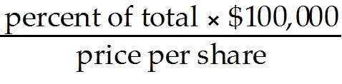
Diff: 2
Section: 12.2 The Market Portfolio
Skill: Analytical
29) Assume that you have $100,000 to invest and you are interested in creating a value-weighted portfolio of these four stocks. The percentage of the shares outstanding of Boeing that you would hold in your portfolio is closest to:
A) .000018%
B) .000020%
C) .000024%
D) .000031%
Answer: C
Explanation: C)
Stock Name | Price per Share | Shares Outstanding (Billions) | Market Capitalization (Billions) | Percent  of Total | Number of Shares
Lowes | $28.80 | 1.53 | $44.06 | 10.6% | 368
Wal-Mart | $47.90 | 4.17 | $199.74 | 48.0% | 1,002
Intel | $19.60 | 5.77 | $113.09 | 27.2% | 1,387
Boeing | $75.00 | 0.79 | $59.25 | 14.2% | 190
 |  | Total | $416.15

Number of shares =
percentage shares outstanding = 190/790000000 = .000024%
Diff: 2
Section: 12.2 The Market Portfolio
Skill: Analytical

30) Assume that you have $250,000 to invest and you are interested in creating a value-weighted portfolio of these four stocks. How many shares of each of the four stocks will you hold? What percentage of the shares outstanding of each stock will you hold?
Answer:
Stock Name | Price per Share | Shares Outstanding (Billions) | Market Capitalization (Billions) | Percent  of Total | Number of Shares
Lowes | $28.80 | 1.53 | $44.06 | 10.6% | 368
Wal-Mart | $47.90 | 4.17 | $199.74 | 48.0% | 1,002
Intel | $19.60 | 5.77 | $113.09 | 27.2% | 1,387
Boeing | $75.00 | 0.79 | $59.25 | 14.2% | 190
 |  | Total | $416.15
 |  | % of Shares | 0.000060%

Number of shares =
In a value weighted portfolio, the percentage of shares of every stock will be the same.
Diff: 3
Section: 12.2 The Market Portfolio
Skill: Analytical
12.3 Beta Estimation

Use the following information to answer the question(s) below.

Year | Risk-free  Return | Market  Return | Wyatt Oil  Return | Market  Excess  Return | Wyatt Oil  Excess  Return | Beta
2007 | 3.0% | 6.0% | 5.5% | 3.0% | 2.5% | 0.833
2008 | 1.5% | -38.5% | -32.6% | .40% | -34.1% | 0.853
2009 | 1.0% | 22.5% | 19.6% | 21.5% | 18.6% | 0.865

1) Wyatt Oil's average historical return is closest to:
A) -2.50%
B) -3.33%
C) -4.33%
D) -5.17%
Answer: A
Explanation: A) raverage = 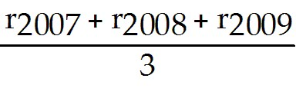
Year | Risk-free  Return | Market  Return | Wyatt Oil  Return | Market  Excess  Return | Wyatt Oil  Excess  Return
2007 | 3.0% | 6.0% | 5.5% | 3.0% | 2.5%
2008 | 1.5% | -38.5% | -32.6% | -40.0% | -34.1%
2009 | 1.0% | 22.5% | 19.6% | 21.5% | 18.6%
Average | 1.83% | -3.33% | -2.50% | -5.17% | -4.33%
Diff: 1
Section: 12.3 Beta Estimation
Skill: Analytical

2) The Market's average historical return is closest to:
A) -2.50%
B) -3.33%
C) -4.33%
D) -5.17%
Answer: B
Explanation: B) raverage =
Year | Risk-free  Return | Market  Return | Wyatt Oil  Return | Market  Excess  Return | Wyatt Oil  Excess  Return
2007 | 3.0% | 6.0% | 5.5% | 3.0% | 2.5%
2008 | 1.5% | -38.5% | -32.6% | -40.0% | -34.1%
2009 | 1.0% | 22.5% | 19.6% | 21.5% | 18.6%
Average | 1.83% | -3.33% | -2.50% | -5.17% | -4.33%
Diff: 1
Section: 12.3 Beta Estimation
Skill: Analytical
3) Wyatt Oil's average historical excess return is closest to:
A) -2.50%
B) -3.33%
C) -4.33%
D) -5.17%
Answer: C
Explanation: C) excess returnaverage = 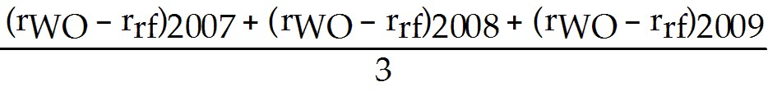
Year | Risk-free  Return | Market  Return | Wyatt Oil  Return | Market  Excess  Return | Wyatt Oil  Excess  Return
2007 | 3.0% | 6.0% | 5.5% | 3.0% | 2.5%
2008 | 1.5% | -38.5% | -32.6% | -40.0% | -34.1%
2009 | 1.0% | 22.5% | 19.6% | 21.5% | 18.6%
Average | 1.83% | -3.33% | -2.50% | -5.17% | -4.33%
Diff: 2
Section: 12.3 Beta Estimation
Skill: Analytical

4) The Market's average historical excess return is closest to:
A) -2.50%
B) -3.33%
C) -4.33%
D) -5.17%
Answer: D
Explanation: D) excess returnaverage =
Year | Risk-free  Return | Market  Return | Wyatt Oil  Return | Market  Excess  Return | Wyatt Oil  Excess  Return
2007 | 3.0% | 6.0% | 5.5% | 3.0% | 2.5%
2008 | 1.5% | -38.5% | -32.6% | -40.0% | -34.1%
2009 | 1.0% | 22.5% | 19.6% | 21.5% | 18.6%
Average | 1.83% | -3.33% | -2.50% | -5.17% | -4.33%
Diff: 2
Section: 12.3 Beta Estimation
Skill: Analytical
5) Wyatt Oil's excess return for 2009 is closest to:
A) 18.6%
B) 19.6%
C) 20.0%
D) 21.5%
Answer: A
Explanation: A) excess returne = (rWO - rrf)2009

Year | Risk-free  Return | Market  Return | Wyatt Oil  Return | Market  Excess  Return | Wyatt Oil  Excess  Return
2007 | 3.0% | 6.0% | 5.5% | 3.0% | 2.5%
2008 | 1.5% | -38.5% | -32.6% | -40.0% | -34.1%
2009 | 1.0% | 22.5% | 19.6% | 21.5% | 18.6%
Average | 1.83% | -3.33% | -2.50% | -5.17% | -4.33%
Diff: 1
Section: 12.3 Beta Estimation
Skill: Analytical

6) The Market's excess return for 2008 is closest to:
A) -40.0%
B) -38.5%
C) -37.0%
D) -34.1%
Answer: A
Explanation: A) excess returne = (rWO - rrf)2009

Year | Risk-free  Return | Market  Return | Wyatt Oil  Return | Market  Excess  Return | Wyatt Oil  Excess  Return
2007 | 3.0% | 6.0% | 5.5% | 3.0% | 2.5%
2008 | 1.5% | -38.5% | -32.6% | -40.0% | -34.1%
2009 | 1.0% | 22.5% | 19.6% | 21.5% | 18.6%
Average | 1.83% | -3.33% | -2.50% | -5.17% | -4.33%
Diff: 1
Section: 12.3 Beta Estimation
Skill: Analytical
7) Using the average historical excess returns for both Wyatt Oil and the Market portfolio, your estimate of Wyatt Oil's Beta is closest to:
A) 0.75
B) 0.84
C) 1.00
D) 1.19
Answer: B
Explanation: B) excess returnaverage = 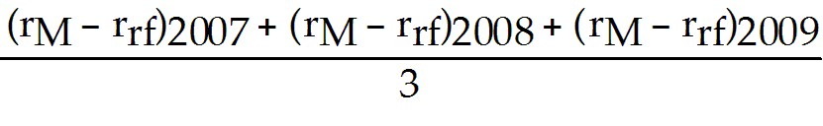
excess returnaverage =
Year | Risk-free  Return | Market  Return | Wyatt Oil  Return | Market  Excess  Return | Wyatt Oil  Excess  Return
2007 | 3.0% | 6.0% | 5.5% | 3.0% | 2.5%
2008 | 1.5% | -38.5% | -32.6% | -40.0% | -34.1%
2009 | 1.0% | 22.5% | 19.6% | 21.5% | 18.6%
Average | 1.83% | -3.33% | -2.50% | -5.17% | -4.33%

βWO= 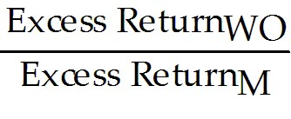 = 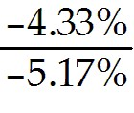 = .8375
Diff: 3
Section: 12.3 Beta Estimation
Skill: Analytical
8) Using the average historical excess returns for both Wyatt Oil and the Market portfolio estimate of Wyatt Oil's Beta. When using this beta, the alpha for Wyatt oil in 2007 is closest to:
A) -0.5000%
B) -0.0250%
C) -0.0125%
D) +0.0250%
Answer: C
Explanation: C) excess returnaverage =
excess returnaverage =
Year | Risk-free  Return | Market  Return | Wyatt Oil  Return | Market  Excess  Return | Wyatt Oil  Excess  Return
2007 | 3.0% | 6.0% | 5.5% | 3.0% | 2.5%
2008 | 1.5% | -38.5% | -32.6% | -40.0% | -34.1%
2009 | 1.0% | 22.5% | 19.6% | 21.5% | 18.6%
Average | 1.83% | -3.33% | -2.50% | -5.17% | -4.33%

βWO = = = .8375
α = actual return - expected return for CAPM
= 5.5% - [3% + .8375(6% - 3%)] = -.0125%
Diff: 3
Section: 12.3 Beta Estimation
Skill: Analytical

9) Using just the return data for 2009, your estimate of Wyatt Oil's Beta is closest to:
A) 0.84
B) 0.87
C) 1.00
D) 1.16
Answer: B
Explanation: B)
Year | Risk-free  Return | Market  Return | Wyatt Oil  Return | Market  Excess  Return | Wyatt Oil  Excess  Return
2007 | 3.0% | 6.0% | 5.5% | 3.0% | 2.5%
2008 | 1.5% | -38.5% | -32.6% | -40.0% | -34.1%
2009 | 1.0% | 22.5% | 19.6% | 21.5% | 18.6%
Average | 1.83% | -3.33% | -2.50% | -5.17% | -4.33%

βWO = = 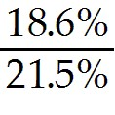 = .8651
Diff: 2
Section: 12.3 Beta Estimation
Skill: Analytical
10) Using just the return data for 2008, your estimate of Wyatt Oil's Beta is closest to:
A) 0.85
B) 0.87
C) 1.00
D) 1.17
Answer: A
Explanation: A)
Year | Risk-free  Return | Market  Return | Wyatt Oil  Return | Market  Excess  Return | Wyatt Oil  Excess  Return
2007 | 3.0% | 6.0% | 5.5% | 3.0% | 2.5%
2008 | 1.5% | -38.5% | -32.6% | -40.0% | -34.1%
2009 | 1.0% | 22.5% | 19.6% | 21.5% | 18.6%
Average | 1.83% | -3.33% | -2.50% | -5.17% | -4.33%

βWO = - 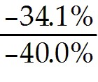 = .8525
Diff: 2
Section: 12.3 Beta Estimation
Skill: Analytical

11) Which of the following statements is FALSE?
A) Beta is the expected percent change in the excess return of the security for a 1% change in the excess return of the market portfolio.
B) Beta represents the amount by which risks that affect the overall market are amplified for a given stock or investment.
C) It is common practice to estimate beta based on the historical correlation and volatilities.
D) Beta measures the diversifiable risk of a security, as opposed to its market risk, and is the appropriate measure of the risk of a security for an investor holding the market portfolio.
Answer: D
Explanation: D) Beta measures the nondiversifiable risk of a security.
Diff: 1
Section: 12.3 Beta Estimation
Skill: Conceptual

12) Which of the following statements is FALSE?
A) One difficulty when trying to estimate beta for a security is that beta depends on the correlation and volatilities of the security's and market's returns in the future.
B) It is common practice to estimate beta based on the expectations of future correlations and volatilities.
C) One difficulty when trying to estimate beta for a security is that beta depends on investors expectations of the correlation and volatilities of the security's and market's returns.
D) Securities that tend to move less than the market have betas below 1.
Answer: B
Explanation: B) Beta is measured using past information.
Diff: 1
Section: 12.3 Beta Estimation
Skill: Conceptual
13) Which of the following statements is FALSE?
A) Securities that tend to move more than the market have betas higher than 0.
B) Securities whose returns tend to move in tandem with the market on average have a beta of 1.
C) Beta corresponds to the slope of the best fitting line in the plot of the securities excess returns versus the market excess return.
D) The statistical technique that identifies the bets-fitting line through a set of points is called linear regression.
Answer: A
Diff: 2
Section: 12.3 Beta Estimation
Skill: Conceptual

Use the equation for the question(s) below.

Consider the following linear regression model:

(Ri - rf) = ai + bi(RMkt - rf) + ei

14) The bi in the regression
A) measures the sensitivity of the security to market risk.
B) measures the historical performance of the security relative to the expected return predicted by the SML.
C) measures the deviation from the best fitting line and is zero on average.
D) measures the diversifiable risk in returns.
Answer: A
Diff: 2
Section: 12.3 Beta Estimation
Skill: Conceptual

15) The ai in the regression
A) measures the sensitivity of the security to market risk.
B) measures the deviation from the best fitting line and is zero on average.
C) measures the diversifiable risk in returns.
D) measures the historical performance of the security relative to the expected return predicted by the SML.
Answer: D
Diff: 2
Section: 12.3 Beta Estimation
Skill: Conceptual

16) The ei in the regression
A) measures the market risk in returns.
B) measures the deviation from the best fitting line and is zero on average.
C) measures the sensitivity of the security to market risk.
D) measures the historical performance of the security relative to the expected return predicted by the SML.
Answer: B
Diff: 2
Section: 12.3 Beta Estimation
Skill: Conceptual
12.4 The Debt Cost of Capital

Use the following information to answer the question(s) below.

Consider the following information regarding corporate bonds:

Rating | AAA | AA | A | BBB | BB | B | CCC
Average Default Rate | 0.0% | 0.1% | 0.2% | 0.5% | 2.2% | 5.5% | 12.2%
Recession Default Rate | 0.0% | 1.0% | 3.0% | 3.0% | 8.0% | 16.0% | 48.0%
Average Beta | 0.05 | 0.05 | 0.05 | 0.10 | 0.17 | 0.26 | 0.31

1) Wyatt Oil has a bond issue outstanding with seven years to maturity, a yield to maturity of 7.0%, and a BBB rating. The corresponding risk-free rate is 3% and the market risk premium is 5%. Assuming a normal economy, the expected return on Wyatt Oil's debt is closest to:
A) 3.0%
B) 3.5%
C) 4.9%
D) 5.5%
Answer: B
Explanation: B) rd = rrf + β(rm - rrf) = 3% + 0.1(5%) = 3.5%
Diff: 1
Section: 12.4 The Debt Cost of Capital
Skill: Analytical

2) Wyatt Oil has a bond issue outstanding with seven years to maturity, a yield to maturity of 7.0%, and a BBB rating. The bondholders' expected loss rate in the event of default is 70%. Assuming a normal economy the expected return on Wyatt Oil's debt is closest to:
A) 3.0%
B) 3.5%
C) 4.9%
D) 6.7%
Answer: D
Explanation: D) rd = ytm - prob(default) × loss rate = 7% - 0.4%(70%) = 6.72%
Diff: 2
Section: 12.4 The Debt Cost of Capital
Skill: Analytical

3) Wyatt Oil has a bond issue outstanding with seven years to maturity, a yield to maturity of 7.0%, and a BBB rating. The bondholders' expected loss rate in the event of default is 70%. Assuming the economy is in recession, then the expected return on Wyatt Oil's debt is closest to:
A) 3.5%
B) 4.9%
C) 5.5%
D) 7.0%
Answer: B
Explanation: B) rd = ytm - prob(default) × loss rate = 7% - 3.0%(70%) = 4.9%
Diff: 2
Section: 12.4 The Debt Cost of Capital
Skill: Analytical
4) Rearden Metal has a bond issue outstanding with ten years to maturity, a yield to maturity of 8.6%, and a B rating. The corresponding risk-free rate is 3% and the market risk premium is 6%. Assuming a normal economy, the expected return on Rearden Metal's debt is closest to:
A) 0.6%
B) 1.6%
C) 4.6%
D) 6.0%
Answer: C
Explanation: C) rd = rrf + β(rm - rrf) = 3% + 0.26(6%) = 4.56%
Diff: 1
Section: 12.4 The Debt Cost of Capital
Skill: Analytical

5) Rearden Metal has a bond issue outstanding with ten years to maturity, a yield to maturity of 8.6%, and a B rating. The bondholders expected loss rate in the event of default is 50%. Assuming a normal economy the expected return on Rearden Metal's debt is closest to:
A) 0.6%
B) 1.6%
C) 4.6%
D) 6.0%
Answer: D
Explanation: D) rd = ytm - prob(default) × loss rate = 8.6% - 5.2%(50%) = 6.00%
Diff: 2
Section: 12.4 The Debt Cost of Capital
Skill: Analytical

6) Rearden Metal has a bond issue outstanding with ten years to maturity, a yield to maturity of 8.6%, and a B rating. The bondholders expected loss rate in the event of default is 50%. Assuming the economy is in recession, then the expected return on Rearden Metal's debt is closest to:
A) 0.6%
B) 1.6%
C) 4.6%
D) 6.0%
Answer: A
Explanation: A) rd = ytm - prob(default) × loss rate = 8.6% - 16.0%(50%) = 0.6%
Diff: 2
Section: 12.4 The Debt Cost of Capital
Skill: Analytical
7) Nielson Motors plans to issue 10-year bonds that it believes will have an BBB rating. Suppose AAA bonds with the same maturity have a 3.5% yield. Assume that the market risk premium is 5% and the expected loss rate in the event of default on the bonds is 60%. The yield that these bonds will have to pay during average economic times is closest to:
A) 3.50%
B) 3.75%
C) 4.00%
D) 5.50%
Answer: C
Explanation: C) For AAA rd = rrf + β(rm - rrf) = rrf + 0.05(5%) = 3.5% → rrf = 3.25%
For BBB rd = rrf + β(rm - rrf) = 3.25% + 0.10(5%) = 3.75%
rd = ytm - prob(default) × loss rate → 3.75% = ytm - 0.4%(60%) → ytm = 3.99%
Diff: 3
Section: 12.4 The Debt Cost of Capital
Skill: Analytical

8) Nielson Motors plans to issue 10-year bonds that it believes will have an BBB rating. Suppose AAA bonds with the same maturity have a 3.5% yield. Assume that the market risk premium is 5% and the expected loss rate in the event of default on the bonds is 60%. The yield that these bonds will have to pay during a recession is closest to:
A) 3.50%
B) 3.75%
C) 4.00%
D) 5.50%
Answer: D
Explanation: D) For AAA rd = rrf + β(rm - rrf) = rrf + 0.05(5%) = 3.5% → rrf = 3.25%
For BBB rd = rrf + β(rm - rrf) = 3.25% + 0.10(5%) = 3.75%
rd = ytm - prob(default) × loss rate → 3.75% = ytm - 3.0%(60%) → ytm = 5.55%
Diff: 3
Section: 12.4 The Debt Cost of Capital
Skill: Analytical
12.5 A Project's Cost of Capital

Use the following information to answer the question(s) below.

Consider the following information regarding corporate bonds:

Rating | AAA | AA | A | BBB | BB | B | CCC
Average Default Rate | 0.0% | 0.1% | 0.2% | 0.45% | 2.2% | 5.5% | 12.2%
Recession Default Rate | 0.0% | 1.0% | 3.0% | 3.0% | 8.0% | 16.0% | 48.0%
Average Beta | 0.05 | 0.05 | 0.05 | 0.10 | 0.17 | 0.26 | 0.31

Company | Market  Capitalization  ($mm) | Total  Enterprise  Value ($mm) | Equity  Beta | Debt  Rating
Taggart Transcontinental | $4,500 | 8,000 | 1.1 | BBB
Rearden Metal | $3,800 | 7,200 | 1.3 | AAA
Wyatt Oil | $2,400 | 3,800 | 0.9 | A
Nielson Motors | $1,500 | 4,400 | 1.75 | BB

1) Your estimate of the debt beta for Taggart Transcontinental would be:
A) 0.05
B) 0.10
C) 0.17
D) 1.00
Answer: B
Explanation: B) Since Taggart has a rating of BBB, the appropriate debt beta from the table is 0.10.
Diff: 1
Section: 12.5 A Project's Cost of Capital
Skill: Analytical

2) Your estimate of the debt beta for Nielson Motors would be:
A) 0.10
B) 0.17
C) 1.00
D) 1.68
Answer: B
Explanation: B) Since Nielson has a rating of BB, the appropriate debt beta from the table is 0.17.
Diff: 1
Section: 12.5 A Project's Cost of Capital
Skill: Analytical
3) Your estimate of the asset beta for Taggart Transcontinental is closest to:
A) 0.42
B) 0.59
C) 0.66
D) 0.71
Answer: C
Explanation: C) Since Taggart has a rating of BBB, the appropriate debt beta from the table is 0.10.
βU = 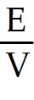βE + βD = 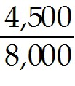 × 1.1 + 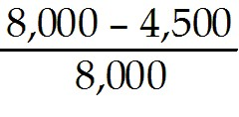 × 0.10 = 0.6625
Diff: 2
Section: 12.5 A Project's Cost of Capital
Skill: Analytical

4) Your estimate of the asset beta for Rearden Metal is closest to:
A) 0.42
B) 0.59
C) 0.66
D) 0.71
Answer: D
Explanation: D) Since Rearden has a rating of AAA, the appropriate debt beta from the table is 0.05.
βU = βE + βD = 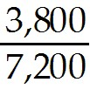 × 1.3 + 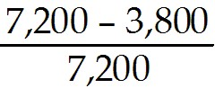 × 0.05 = 0.709722
Diff: 2
Section: 12.5 A Project's Cost of Capital
Skill: Analytical

5) Your estimate of the asset beta for Wyatt Oil is closest to:
A) 0.59
B) 0.66
C) 0.71
D) 0.90

Answer: A
Explanation: A) Since Wyatt has a rating of A, the appropriate debt beta from the table is 0.05.
βU = βE + βD = 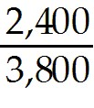 × 0.9 + 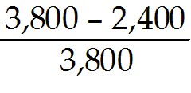 × 0.05 = 0.586842
Diff: 2
Section: 12.5 A Project's Cost of Capital
Skill: Analytical
6) Your estimate of the asset beta for Nielson Motors is closest to:
A) 0.59
B) 0.66
C) 0.71
D) 1.75
Answer: C
Explanation: C) Since Nielson has a rating of BB, the appropriate debt beta from the table is 0.17.
βU = βE + βD = 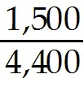 × 1.75 + 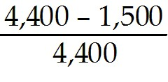 × 0.17 = 0.708636
Diff: 2
Section: 12.5 A Project's Cost of Capital
Skill: Analytical

7) Suppose that because of the large need for steel in building railroad infrastructure, Taggart Transcontinental and Rearden Metal decide to form into one large conglomerate. Your estimate of the asset beta for this new conglomerate is closest to:
A) 0.42
B) 0.59
C) 0.66
D) 0.68
Answer: D
Explanation: D) Since Taggart has a rating of BBB, the appropriate debt beta from the table is 0.10.
βU = βE + βD = × 1.1 + × 0.10 = 0.6625
Since Rearden has a rating of AAA, the appropriate debt beta from the table is 0.05.
βU = βE + βD = × 1.3 + × 0.05 = 0.709722

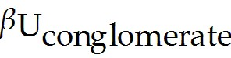 = WTT 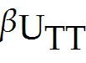 + WRM 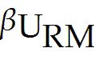
= 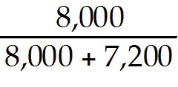 (0.6625) + 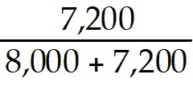 (0.709722) = 0.684868
Diff: 2
Section: 12.5 A Project's Cost of Capital
Skill: Analytical
Use the following information to answer the question(s) below.

Consider the following information regarding corporate bonds:

Rating | AAA | AA | A | BBB | BB | B | CCC
Average Default Rate | 0.0% | 0.1% | 0.2% | 0.5% | 2.2% | 5.5% | 12.2%
Recession Default Rate | 0.0% | 1.0% | 3.0% | 3.0% | 8.0% | 16.0% | 48.0%
Average Beta | 0.05 | 0.05 | 0.05 | 0.10 | 0.17 | 0.26 | 0.31

8) Galt Industries has a market capitalization of $50 billion, $30 billion in BBB rated debt, and $8 billion in cash. If Galt's equity beta is 1.15, then Galt's underlying asset beta is closest to:
A) 0.83
B) 0.92
C) 1.00
D) 1.15
Answer: A
Explanation: A) We can think of Galt's business assets as a portfolio of equity, plus debt, and less cash. Assuming the beta of cash investments is zero:
βU = 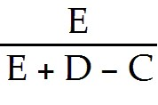βE + 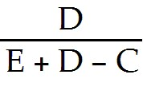βD + 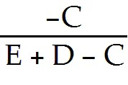βC
= 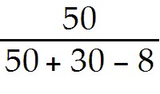 × 1.15 + 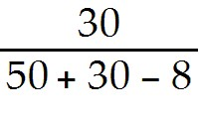 × 0.10 -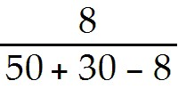 × 0.0
= 0.84
Alternatively, we estimate Galt's asset beta based on its net debt of 30-8=22 m. Using net debt:
βU = βE + 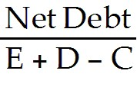βD
= × 1.15 + 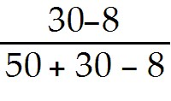 × 0.10
= 0.829
Note that both answers are quite similar. The second approach presumes that Galt's cash reduces the average market risk of its debt (as thought Galt used its cash to repay its senior debt).
Diff: 2
Section: 12.5 A Project's Cost of Capital
Skill: Analytical
9) Trucks R' Us has a market capitalization of $142 billion, $78 billion in BB rated debt, and $10 billion in cash. If Trucks R' Us' equity beta is 1.68, then their underlying asset beta is closest to:
A) 1.00
B) 1.20
C) 1.32
D) 1.48
Answer: B
Explanation: B) We can think of Trucks R' Us business assets as a portfolio of equity, plus debt, and less cash. Assuming the beta of cash investments is zero:
βU = βE + βD + βC
= 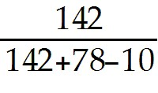 × 1.68 + 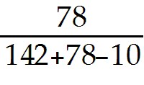 × 0.17 - 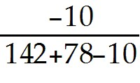 × 0.0
= 1.199
Alternatively, we estimate asset beta based on its net debt of 78-10=68 m. Using net debt:
βU = βE + βD
= × 1.15 + 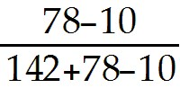 × 0.17
= 1.191
Note that both answers are quite similar. The second approach presumes that TRU's cash reduces the average market risk of its debt (as thought TRU used its cash to repay its senior debt).

Diff: 2
Section: 12.5 A Project's Cost of Capital
Skill: Analytical

10) Luther Industries has a market capitalization of $23 billion, no debt, and $4 billion in cash. If Luther's estimated equity beta is 1.32, then the beta of Luther's underlying business enterprise is closest to:
A) 1.09
B) 1.32
C) 1.48
D) 1.60
Answer: D
Explanation: D) βU = 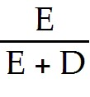βE + 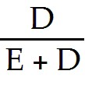βD = 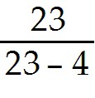 × 1.32 + 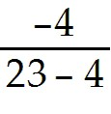 × 0 = 1.597895
Diff: 2
Section: 12.5 A Project's Cost of Capital
Skill: Analytical
11) Your firm is planning to invest in a new power generation system. Galt Industries is an all equity firm that specializes in this business. Suppose Galt's equity beta is 0.75, the risk-free rate is 3%, and the market risk premium is 6%. If your firm's project is all equity financed, then your estimate of your cost of capital is closest to:
A) 5.25%
B) 6.00%
C) 6.75%
D) 7.50%
Answer: D
Explanation: D) ri = rrf + β(rm - rrf) = .03 + .75(.06) = .075 or 7.5%
Diff: 1
Section: 12.5 A Project's Cost of Capital
Skill: Analytical

12) Your firm is planning to invest in a new electrostatic power generation system. Electrostat Inc is a firm that specializes in this business. Electrostat has a stock price of $25 per share with 16 million shares outstanding. Electrostat's equity beta is 1.18. It also has $220 million in debt outstanding with a debt beta of 0.08. Your estimate of the asset beta for electrostatic power generators is closest to:
A) 0.76
B) 0.79
C) 0.93
D) 1.10
Answer: B
Explanation: B) βU = βE + βD = 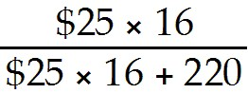 × 1.18 + 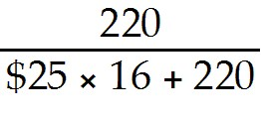 × 0.08 = 0.789677
Diff: 2
Section: 12.5 A Project's Cost of Capital
Skill: Analytical

13) Your firm is planning to invest in a new electrostatic power generation system. Electrostat Inc is a firm that specializes in this business. Electrostat has a stock price of $25 per share with 16 million shares outstanding. Electrostat's equity beta is 1.18. It also has $220 million in debt outstanding with a debt beta of 0.08. If the risk-free rate is 3%, and the market risk premium is 6%, then your estimate of your cost of capital for electrostatic power generators is closest to:
A) 7.50%
B) 7.75%
C) 9.50%
D) 10.10%
Answer: B
Explanation: D) βU = βE + βD = × 1.18 + × 0.08 = 0.789677
ri = rrf + β(rm - rrf) = .03 + .789677(.06) = .07738 or 7.74%
Diff: 3
Section: 12.5 A Project's Cost of Capital
Skill: Analytical
14) The firm's unlevered (asset) beta is:
A) the weighted average of the equity beta and the debt beta.
B) the weighted average of the levered beta and the equity beta.
C) the debt beta minus the equity beta.
D) the unlevered beta minus the cost of capital.
Answer: A
Diff: 1
Section: 12.5 A Project's Cost of Capital
Skill: Definition

15) The firm's unlevered (asset) cost of capital is:
A) the weighted average of the equity cost of capital and the debt cost of capital.
B) the weighted average of the levered cost of capital and the equity cost of capital.
C) the debt cost of capital minus the equity cost of capital.
D) the unlevered beta minus the cost of capital.
Answer: A
Diff: 1
Section: 12.5 A Project's Cost of Capital
Skill: Definition

16) If a firm's excess cash holdings are greater than its debt, using net debt as the measure of leverage will result in:
A) its unlevered beta and cost of capital equalling zero.
B) its unlevered beta and cost of capital being greater than its equity beta and cost of capital.
C) the risk of the firm's equity being increased by its cash holdings in excess of its operating needs.
D) the risk of the firm's debt being increased by its cash holdings in excess of its operating needs.
Answer: B
Diff: 1
Section: 12.5 A Project's Cost of Capital
Skill: Definition

17) Which of the following is true of asset betas?
A) Asset betas are expected to vary greatly within firms in the same industry.
B) Businesses that are less sensitive to market and economic conditions tend to have higher asset betas than more cyclical industries.
C) Businesses that are less sensitive to market and economic conditions tend to have lower asset betas than more cyclical industries.
D) A and B are correct.
Answer: C
Diff: 1
Section: 12.5 A Project's Cost of Capital
Skill: Definition
12.6 Project Risk Characteristics and Financing

Use the following information to answer the question(s) below.

Division | Asset  Beta | Next Period's Expected Free Cash  Flow ($mm) | Expected  Growth  Rate
Oil Exploration | 1.4 | 450 | 4.0%
Oil Refining | 1.1 | 525 | 2.5%
Gas & Convenience Stores | 0.8 | 600 | 3.0%

The risk-free rate of interest is 3% and the market risk premium is 5%.

1) The cost of capital for the oil exploration division is closest to:
A) 6.0%
B) 7.0%
C) 8.5%
D) 10.0%
Answer: D
Explanation: D) ri = rrf + β(rm - rrf) = .03 + 1.4(.05) = .10 or 10.0%
Diff: 1
Section: 12.6 Project Risk Characteristics and Financing
Skill: Analytical

2) The cost of capital for the oil refining division is closest to:
A) 6.5%
B) 7.0%
C) 8.5%
D) 10.0%
Answer: C
Explanation: C) ri = rrf + β(rm - rrf) = .03 + 1.1(.05) = .085 or 8.5%
Diff: 1
Section: 12.6 Project Risk Characteristics and Financing
Skill: Analytical

3) The value of the oil exploration division is closest to:
A) $4,500
B) $7,500
C) $8,750
D) $10,000
Answer: B
Explanation: B) ri = rrf + β(rm - rrf) = .03 + 1.4(.05) = .10 or 10.0%
V = 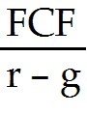 = 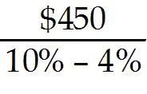 = $7,500
Diff: 2
Section: 12.6 Project Risk Characteristics and Financing
Skill: Analytical
4) The value of the gas and convenience store division is closest to:
A) $4,500
B) $6,000
C) $8,600
D) $15,000
Answer: D
Explanation: D) ri = rrf + β(rm - rrf) = .03 + 0.8(.05) = .07 or 7.0%
V = = 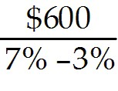 = $15,000
Diff: 2
Section: 12.6 Project Risk Characteristics and Financing
Skill: Analytical

5) The overall value of Wyatt Oil (in $ millions) is closest to:
A) $25,000
B) $18,846
C) $31,250
D) $15,000
Answer: C
Explanation: C) Oil Exploration Division:
ri = rrf + β(rm - rrf) = .03 + 1.4(.05) = .10 or 10.0%
V = = = $7,500
Oil Refining:
ri = rrf + β(rm - rrf) = .03 + 1.1(.05) = .085 or 8.5%
V = = 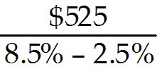 = $8,750
Convenience Store;
ri = rrf + β(rm - rrf) = .03 + 0.8(.05) = .07 or 7.0%
V = = = $15,000
Total Value = 7,500 + 8,750 + 15,000 = $31,250
Diff: 3
Section: 12.6 Project Risk Characteristics and Financing
Skill: Analytical
6) The overall asset beta for Wyatt Oil is closest to:
A) 0.95
B) 1.05
C) 1.15
D) 1.25
Answer: B
Explanation: B) Oil Exploration Division:
ri = rrf + β(rm - rrf) = .03 + 1.4(.05) = .10 or 10.0%
V = = = $7,500
Oil Refining:
ri = rrf + β(rm - rrf) = .03 + 1.1(.05) = .085 or 8.5%
V = = 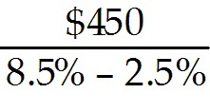 = $8,750
Convenience Store:
ri = rrf + β(rm - rrf) = .03 + 0.8(.05) = .07 or 7.0%
V = = = $15,000
Total Value = 7,500 + 8,750 + 15,000 = $31,250

βWO = wOE βOE+ wOR βOR + wCS βCS
= 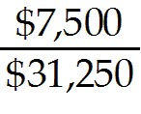(1.4) + 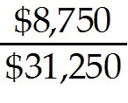(1.1) + 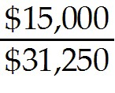(0.8) = 1.028
Diff: 3
Section: 12.6 Project Risk Characteristics and Financing
Skill: Analytical
7) The overall cost of capital for Wyatt Oil is closest to:
A) 8.1%
B) 8.5%
C) 8.8%
D) 9.3%
Answer: A
Explanation: A) Oil Exploration Division:
ri = rrf + β(rm - rrf) = .03 + 1.4(.05) = .10 or 10.0%
V = = = $7,500
Oil Refining:
ri = rrf + β(rm - rrf) = .03 + 1.1(.05) = .085 or 8.5%
V = = = $8,750
Convenience Store:
ri = rrf + β(rm - rrf) = .03 + 0.8(.05) = .07 or 7.0%
V = = = $15,000
Total Value = 7,500 + 8,750 + 15,000 = $31,250

rWO = wOE rOE+ wOR rOR + wCS rCS
= (.10) + (.085) + (.07) = .0814
Diff: 3
Section: 12.6 Project Risk Characteristics and Financing
Skill: Analytical

8) Firms should adjust for execution risk by:
A) assigning a higher cost of capital to new projects.
B) ignoring execution risk since it is diversifiable.
C) capturing this risk in the expected cash flows generated by the project.
D) noticing missteps in the firm's execution of new projects.
Answer: C
Diff: 1
Section: 12.6 Project Risk Characteristics and Financing
Skill: Definition

9) One factor that can affect the market risk of a project is its degree of operating leverage, which is:
A) the relative proportion of operating assets versus non-operating assets.
B) the relative proportion of operating assets versus equity.
C) the relative proportion of operating expenses versus non-operating expenses.
D) the relative proportion of fixed versus variable costs.
Answer: D
Diff: 1
Section: 12.6 Project Risk Characteristics and Financing
Skill: Conceptual
10) If a project has a higher proportion of fixed to variable costs, holding the risk of its revenues constant:
A) its beta will be lower, hence its cost of capital will be lower.
B) its beta will be higher, hence its cost of capital will be higher.
C) its beta will be unaffected, since beta does not measure the sensitivity of the project's cash flows to market risk.
D) its financial leverage will be higher.
Answer: B
Diff: 1
Section: 12.6 Project Risk Characteristics and Financing
Skill: Conceptual

11) The difference between the weighted-average cost of capital (WACC) and the pre-tax (unlevered) WACC is:
A) the weighted-average cost of capital is based on the after-tax cost of equity and the pre-tax WACC is based on the after-tax cost of debt.
B) the weighted-average cost of capital multiplies the cost of equity and the cost of debt by (1-tax rate) and the pre-tax WACC does not.
C) the weighted-average cost of capital multiplies the cost of debt by (1-tax rate) and the pre-tax WACC does not.
D) the weighted-average cost of capital multiplies the component costs of equity and debt by their weight in the capital structure, and the pre-tax WACC does not.
Answer: C
Diff: 1
Section: 12.6 Project Risk Characteristics and Financing
Skill: Definition

12) In a world with taxes, which of the following is the rate we should use to evaluate an all-equity financed project with the same risk as the firm?
A) The weighted-average cost of capital
B) The pre-tax WACC
C) The cost of equity
D) The cost of debt
Answer: B
Diff: 1
Section: 12.6 Project Risk Characteristics and Financing
Skill: Definition

13) In a world with taxes, which of the following is the rate we should use to evaluate a project with the same risk and the same financing as the firm itself?
A) The weighted-average cost of capital
B) The pre-tax WACC
C) The cost of equity
D) The cost of debt
Answer: A
Diff: 1
Section: 12.6 Project Risk Characteristics and Financing
Skill: Definition
Use the following information to answer the question(s) below.

Luther Industries has 25 million shares outstanding trading at $18 per share. In addition, Luther has $150 million in outstanding debt. Suppose Luther's equity cost of capital is 13%, its debt cost of capital is 7%, and the corporate tax rate is 40%.

14) Luther's unlevered cost of capital is closest to:
A) 7.0%
B) 9.8%
C) 10.8%
D) 11.5%
Answer: D
Explanation: D) rU = rE + rD = 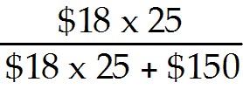(13%) + 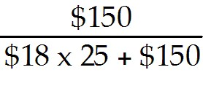(7%) = 11.5%
Diff: 1
Section: 12.6 Project Risk Characteristics and Financing
Skill: Analytical

15) Luther's after-tax debt cost of capital is closest to:
A) 4.2%
B) 5.4%
C) 7.0%
D) 9.8%
Answer: A
Explanation: A) Effective after-tax interest rate = r(1 - Tc) = .07(1 - .40) = .042 or 4.2%
Diff: 1
Section: 12.6 Project Risk Characteristics and Financing
Skill: Analytical

16) Luther's weighted average cost of capital is closest to:
A) 9.8%
B) 10.8%
C) 11.5%
D) 13.0%
Answer: B
Explanation: B) rU = rE + (1 - Tc)
= 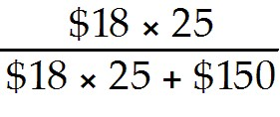(13%) + 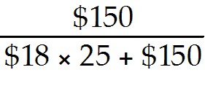(7%)(1 - .4) = 10.8%
Diff: 1
Section: 12.6 Project Risk Characteristics and Financing
Skill: Analytical
12.7 Final Thoughts on Using the CAPM

1) Which of the following is NOT considered a difficulty with regards to the CAPM?
A) Betas are not observed.
B) Expected returns are not observed.
C) The market proxy is not correct.
D) Investors risk preferences are not observed.
Answer: D
Diff: 2
Section: 12.7 Final Thoughts on Using the CAPM
Skill: Conceptual

2) Which of the following is NOT considered to be an important choice when estimating beta?
A) The choice of the time horizon to use for estimation
B) The choice of method used to extrapolate beta
C) The choice between weekly and monthly returns
D) The choice of index used as the market portfolio
Answer: C
Diff: 1
Section: 12.7 Final Thoughts on Using the CAPM
Skill: Conceptual

3) Which of the following statements is FALSE?
A) Many practitioners prefer to use average industry betas rather than individual stock betas.
B) When estimating beta by using past returns it is best to use the longest time horizon of returns available.
C) The CAPM predicts that a security's expected return depends on its beta with regard to the market portfolio of all risky investments available to investors.
D) If we use too short a time horizon when estimating beta, our estimate of beta will be unreliable.
Answer: B
Diff: 1
Section: 12.7 Final Thoughts on Using the CAPM
Skill: Conceptual

4) Which of the following statements is FALSE?
A) We should be suspicious of beta estimates that are extreme relative to industry norms.
B) When using historical data, there is always the possibility of estimation error.
C) Evidence suggests that betas tend to revert toward zero over time.
D) For stocks, common practice is to use at least two years of weekly return data or five years of monthly return data when estimating beta.
Answer: C
Diff: 2
Section: 12.7 Final Thoughts on Using the CAPM
Skill: Conceptual
5) Which of the following statements is FALSE?
A) There may be reasons to exclude certain historical data as anomalous when estimating beta.
B) Many practitioners use adjusted betas, which are calculated by averaging the estimated beta with 1.0.
C) The beta estimated we obtain from linear regression can be very sensitive to outliers, which are returns of unusually small magnitude.
D) If we use very old data to when estimating beta, they data may be unrepresentative of the current market risk of the security.
Answer: C
Diff: 2
Section: 12.7 Final Thoughts on Using the CAPM
Skill: Conceptual

6) Which of the following statements is FALSE?
A) Many practitioners analyze other financial characteristics of a firm, when they forecast betas.
B) U.S. Treasuries are never subject to interest rate risk unless we select a maturity equal to our investment horizon.
C) If a firm where to change industries, using its historical beta would be inferior to using the beta of other firms in the new industry.
D) When using historical returns to forecast future betas, we must be mindful of changes in the environment that might cause the future to differ from the past.
Answer: B
Diff: 2
Section: 12.7 Final Thoughts on Using the CAPM
Skill: Conceptual

7) Which of the following statements is FALSE?
A) The CAPM states that we should use the risk-free interest rate corresponding to the investment horizon of the firm's investors.
B) To determine the risk premium for a stock using the security market line, we need an estimate of the market risk premium.
C) When surveyed, the vast majority of large firms and financial analysts reported using the yields of Treasury Bills to determine the risk-free rate.
D) The risk-free interest rate is generally determined using the yields of U.S. Treasury securities, which are free from default risk.
Answer: C
Diff: 3
Section: 12.7 Final Thoughts on Using the CAPM
Skill: Conceptual
8) Which of the following statements is FALSE?
A) The CAPM remains the predominant model use in practice to determine the equity cost of capital.
B) Low beta stocks have tended to perform somewhat better than the CAPM predicts.
C) The empirically estimated security market line is somewhat steeper than that predicted by the CAPM.
D) Some evidence suggests that the market risk premium has declined over time.
Answer: C
Diff: 3
Section: 12.7 Final Thoughts on Using the CAPM
Skill: Conceptual

9) Which of the following statements is FALSE?
A) The imperfections in the CAPM may be critical in the context of capital budgeting and corporate finance, where errors in estimating the cost of capital are likely to be far more important than small discrepancies in the project cash flows.
B) To estimate the expected market risk premium we can look at the historical average excess return of the market over the risk free interest rate.
C) The highest beta stocks have tended to under perform what the CAPM predicts.
D) Given an assessment of an index's future cash flows, we can estimate the expected return of the market by solving for the discount rate that is consistent with the current level of the index.
Answer: A
Diff: 3
Section: 12.7 Final Thoughts on Using the CAPM
Skill: Conceptual

10) Assume that the S&P 500 currently has a dividend yield of 3% and that on average, the dividends of S&P 500 firms have increased by about 5% per year. If the risk-free interest rate is 4%, then your estimate for the future market risk premium is:
A) 7%
B) 8%
C) 6%
D) 4%
Answer: D
Explanation: D) r = d1/p0 +g = dividend yield + g = .03 + .05 = .08
Risk premium = expected return on market - risk free rate = .08 - .04 = .04
Diff: 2
Section: 12.7 Final Thoughts on Using the CAPM
Skill: Analytical
11) Assume that the Wilshire 5000 currently has a dividend yield of 2% and that on average, the dividends of Wilshire 5000 firms have increased by about 7% per year. If the risk-free interest rate is 4%, then your estimate for the future market risk premium is:
A) 4%
B) 7%
C) 8%
D) 5%
Answer: D
Explanation: D) r = d1/p0 +g = dividend yield + g = .02 + .07 = .09
Risk premium = expected return on market - risk free rate = .09 - .04 = .05
Diff: 2
Section: 12.7 Final Thoughts on Using the CAPM
Skill: Analytical

